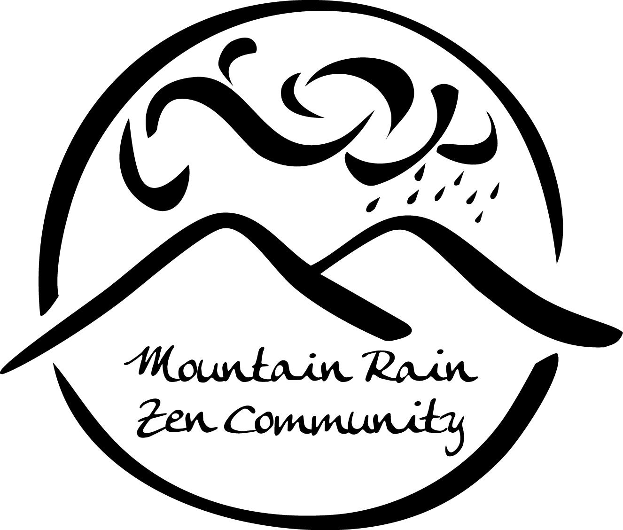Mountain Rain Zen Community

2014 Practice Period Guide

This form is to help you plan your practice period and clarify your intentions in advance. There are no specific requirements. Please take into consideration your family and work commitments and decide what will best nourish your practice.

We encourage you to discuss your experience during practice period with Kate and/or Michael in dokusan. We also encourage you to check in along the way with one of our practice mentors, Susan, Claire or Flo, and to meet with the shuso, Ruth, for tea.

Practice period is a wonderful way to strengthen and nourish your practice, supported by the sangha. We hope you’ll be able to participate in whatever way is best for you.

2014 Fall Practice Period Intentions

Friday, September 26, 2014 – Sunday, November 16, 2014

Date:

Name:

Home practice:

Engaged Buddhist practice (service/activism):

Commitment to simplify or restrict personal lifestyle:

Specific personal mindfulness practice:

Practice at the zendo:

Meetings with resident teachers and practice mentors:

Tea with the shuso (head monk):

Participation in practice period events (see p. 3):

2014 Fall Practice Period Events

Fall Practice Period Opening and Shuso Entering Ceremony
Friday, September 26, 2014
Two zazen periods followed by shuso entering ceremony.

An Undivided Life: A Weekend Retreat
Friday, September 26 – Sunday, September 28, 2014
Practice period opening retreat led by Myoshin Kate McCandless.

Zen Poetry through the Ages
Wednesdays, October 1 – November 5, 2014
A dharma study series with Myoshin Kate McCandless.

Practice/Realization/Expression - Dogen’s Path of Creative Enlightenment: a dharma study class with Shuso Kanshin Ruth Ozeki
Sundays, October 5 – November 2, 2014
A dharma study series with shuso Kanshin Ruth Ozeki.

Buddhist Perspectives on Death, Dying and Loss: The Practice of Forgiveness
Saturday, October 18, 2014
A day retreat with Myoshin Kate McCandless.

Loon Lake Residential Retreat
Saturday, November 8 – Friday, November 14, 2014
Residential Zen retreat at Loon Lake Camp, Maple Ridge, BC, concluding with shuso's Dharma Inquiry Ceremony.

Practice Period Closing Ceremony
Sunday, November 16, 2014
Two periods of zazen and closing ceremony, after which we will take the shuso to lunch.

